**SCREEN SHOTS**

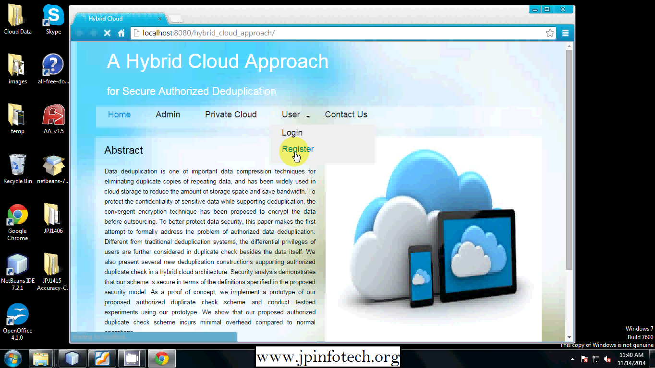

7.1 Screen for Home Page

**User Register Page**

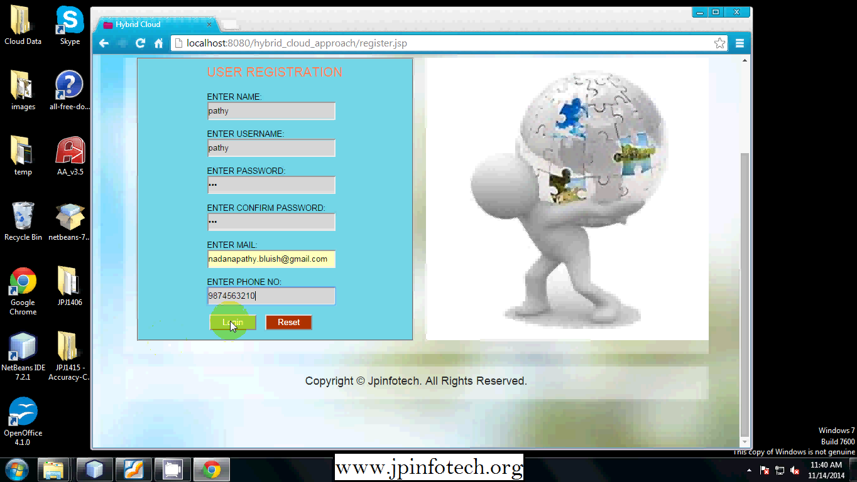

7.2 User Register Page

**7.3 USER LOGIN PAGE**

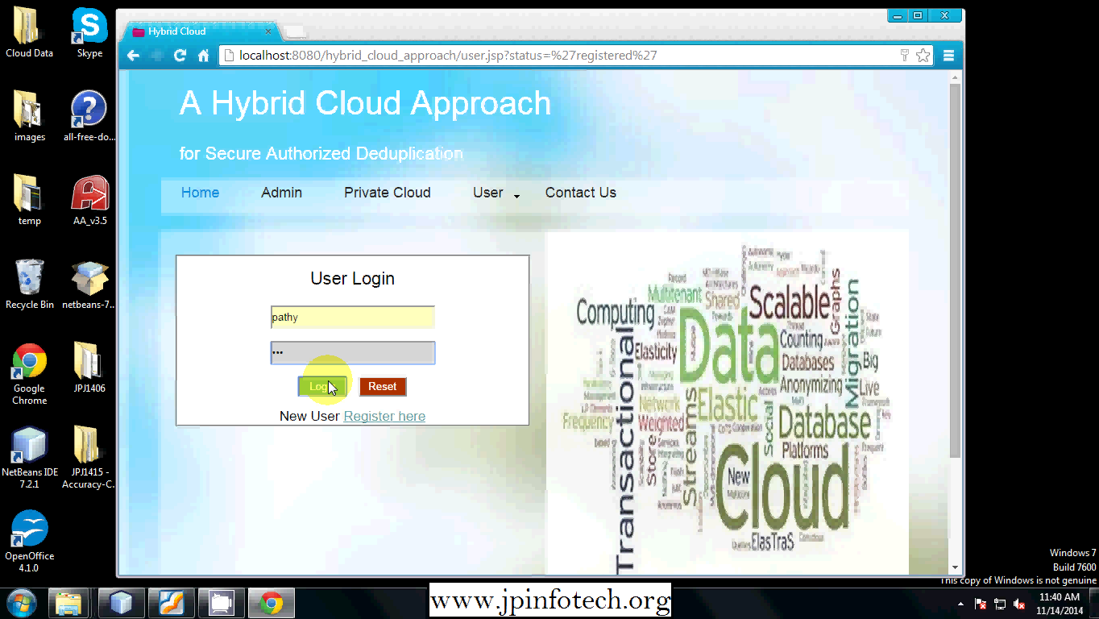

7.3 User Login Page

**7.4 ACCOUNT NOT ACTIVATED**

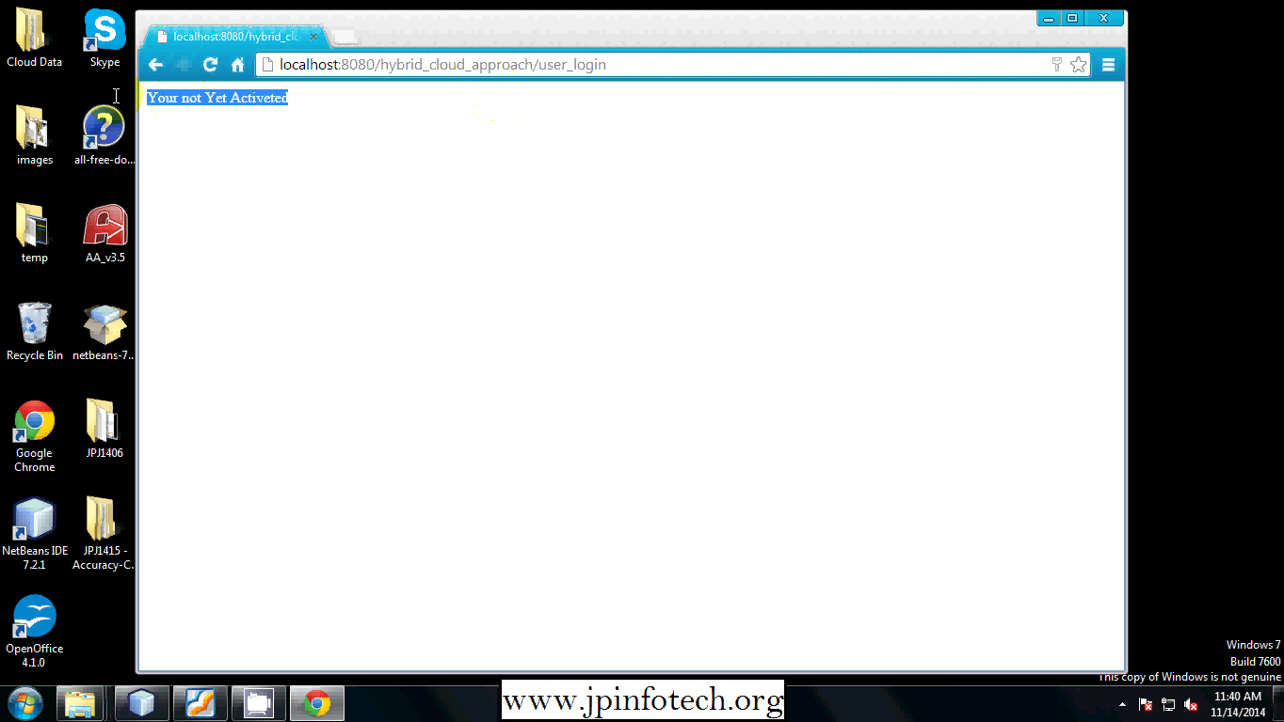

7.4 Account Not AT Activated

**7.5 Cloud Login Page**

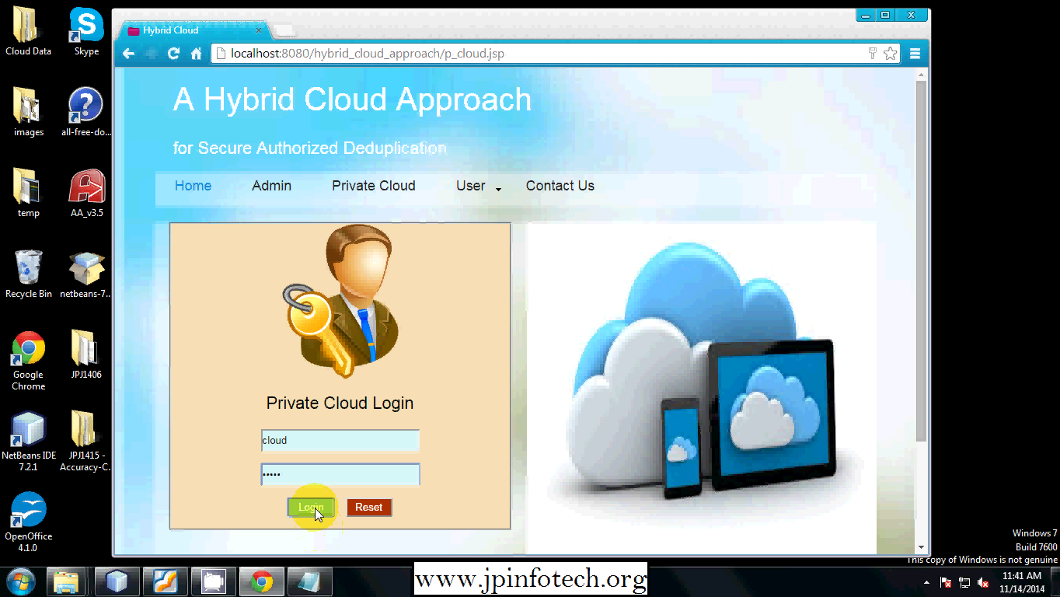

7.5 Cloud Login Page

**Private Cloud Page**

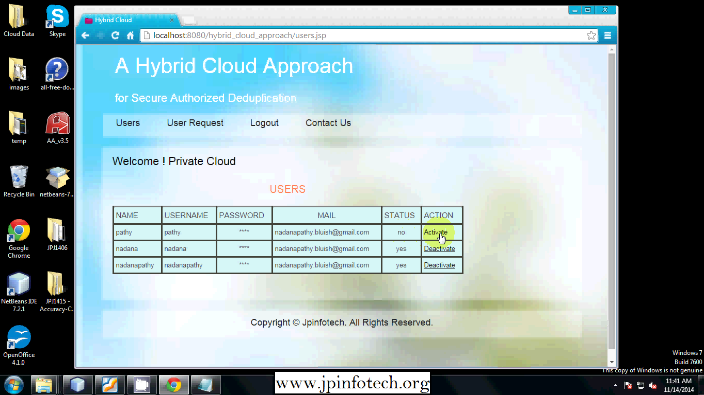

**7.6 Private Cloud Page**

**Permission Page**

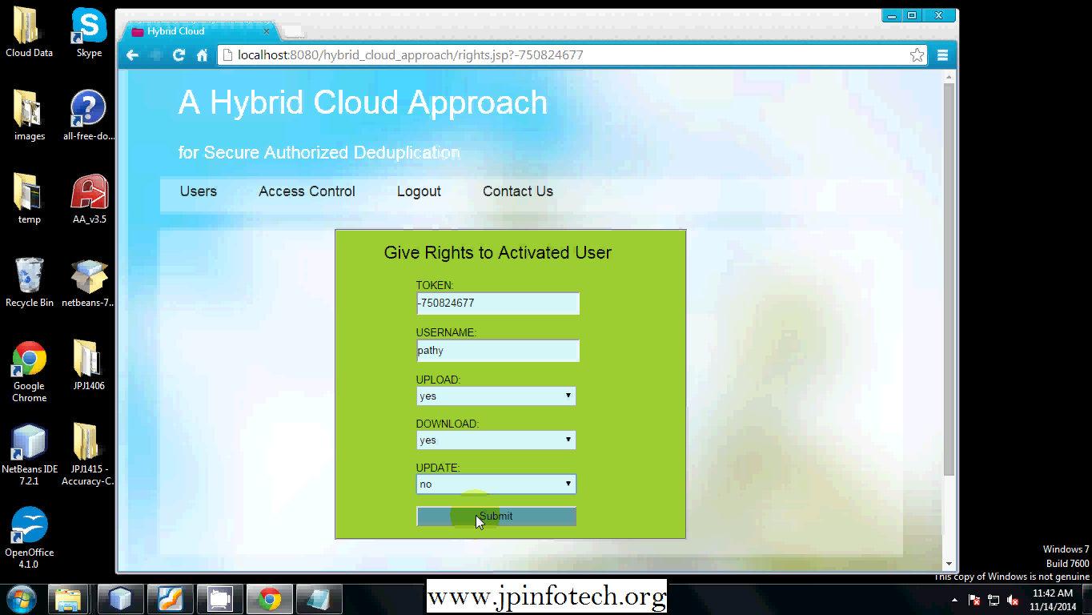

7.7 Permission Page

**7.8 User Login Page**

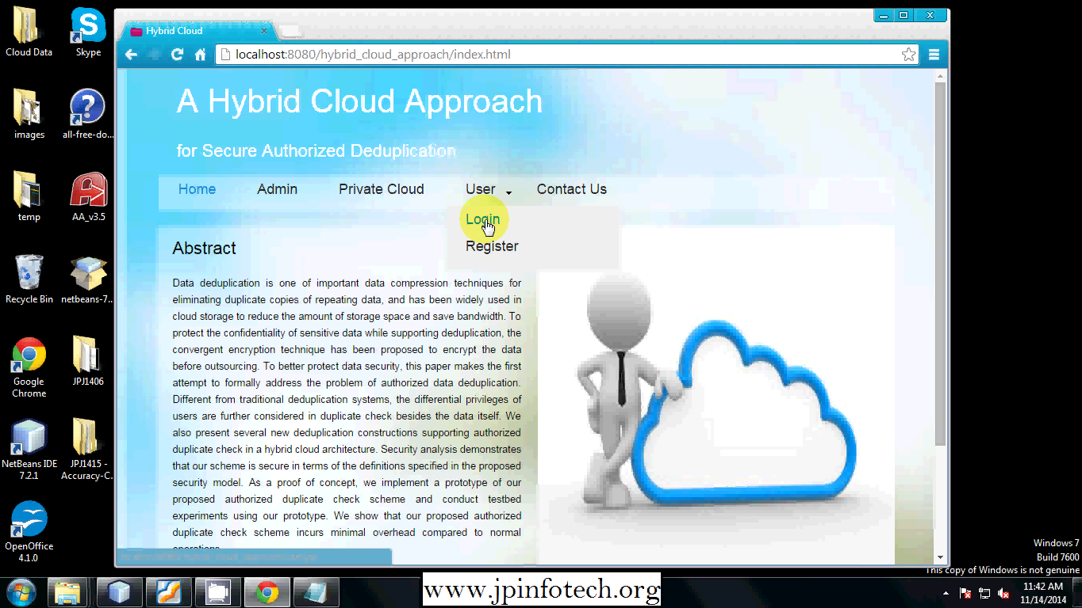

7.8 User Login Page

**7.9 Getting Key From Mail**

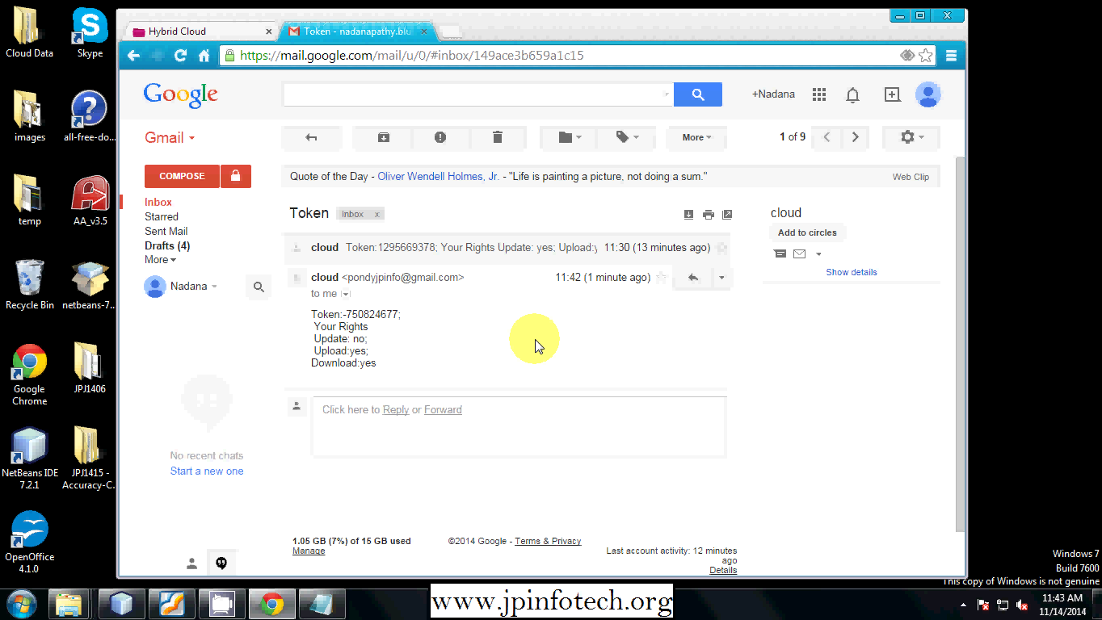

7.9 Getting Key From Mail